1. Reverse a given list in Python

aList = [100, 200, 300, 400, 500]

output:

[500, 400, 300, 200, 100]

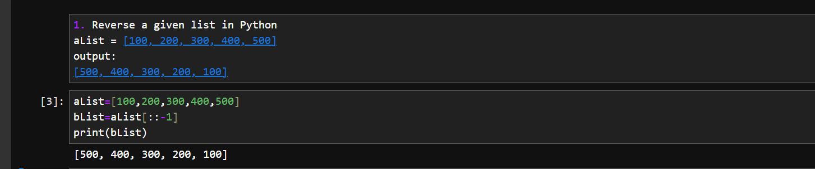

2. take a list 'l1' of even nos between 150 to 250. Print its length.

Then create another list 'l2' using 'l1', containing only nos divisible by 4 from 'l1'.

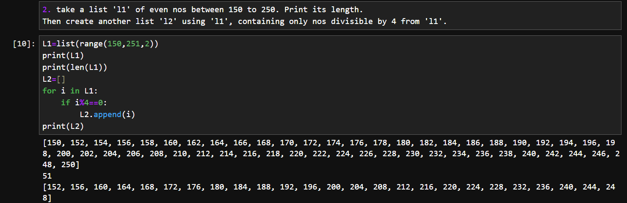

3. Given a Python list of numbers. Turn every item of a list into its square root

aList = [1, 4, 9, 16, 25, 36, 49]

output:

[1, 2, 3, 4, 5, 6, 7]

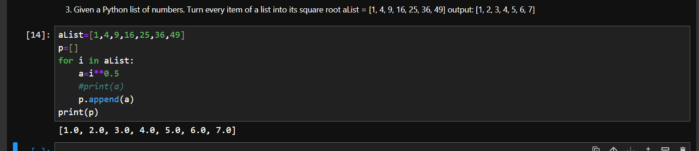

4. Print two lists in the following order

list1 = [5, 6,7]

list2 = [0, 1]

output:

50,51,60,61,70,71

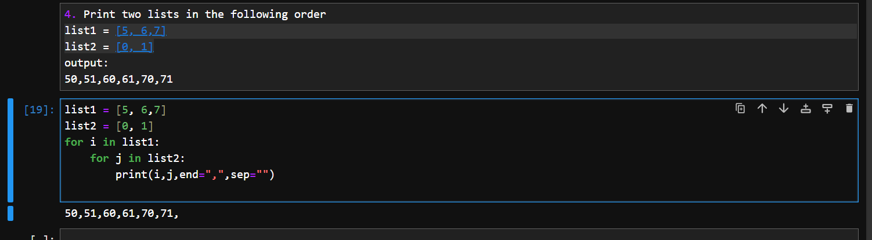

5. Given a two Python list. Iterate both lists simultaneously such that list1 should display item in original order and list2 in reverse order. It should work for any two lists.

list1 = [10, 20, 30, 40]

list2 = [100, 200, 300, 400]

output:

10 400

20 300

30 200

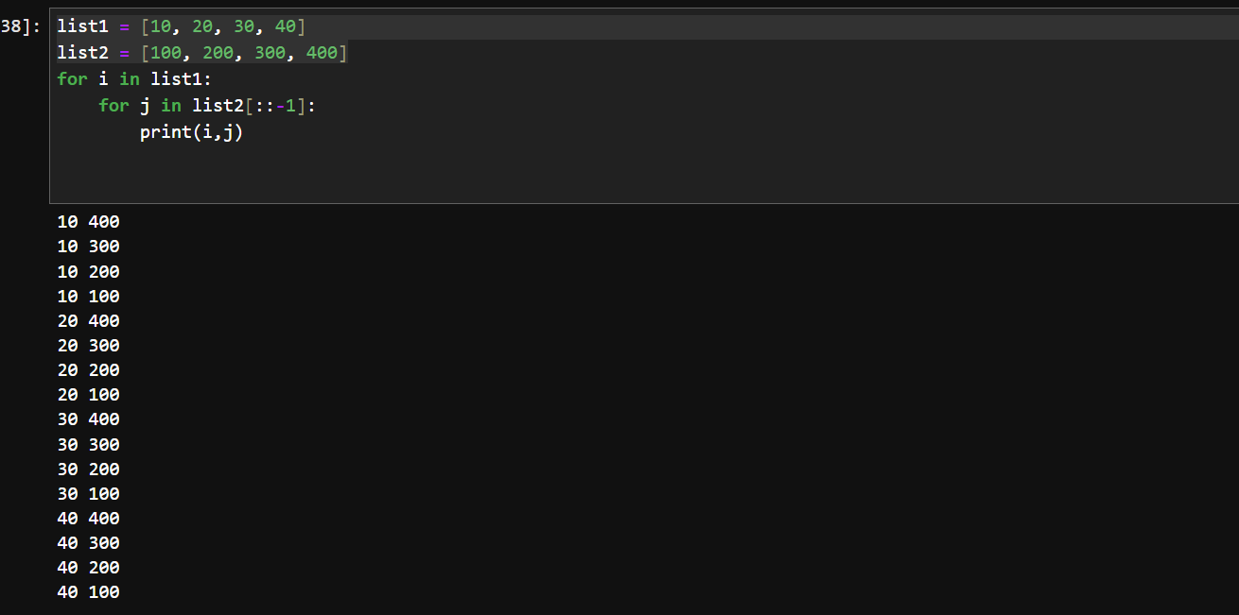

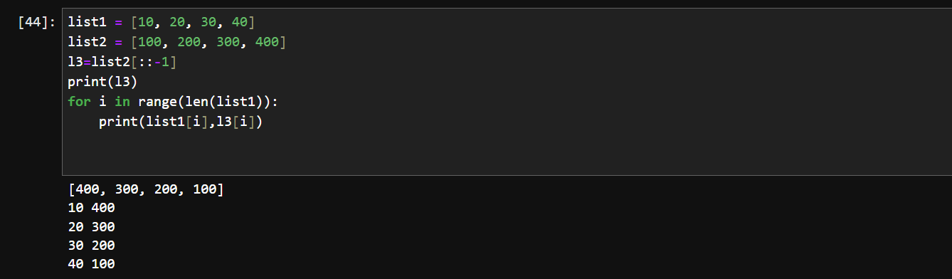

6. Remove empty strings from the list of strings

list1 = ["Ashish", "", "Atharva", "Amit", "", "Revati"]

output:

["Ashish", "Atharva", "Amit", "Revati"]



7. Add item 7000 after 6000 in the following Python List

list1 = [10, 20, [300, 400, [5000, 6000], 500], 30, 40]

output:

[10, 20, [300, 400, [5000, 6000, 7000], 500], 30, 40]